
IILM University
School of Computer Science and Engineering
Internship Report
E-GOVERNANCE & DIGITAL SERVICES
Responsive Web Design, Quality Assurance and Security Audit
Submitted To
School of Computer Science and Engineering
IILM University, Greater Noida, U.P.
In partial fulfilment of the requirement of degree of
B.Tech CSE
Submitted By:-Akriti Agarwal
Roll Number: 25SCS1003001686
Program: B.Tech – Computer Science & Engineering (AI/ML)
Semester: 3rd Semester
Batch: 2026–2027
Organization: YuvaIntern
Internship Role: Junior Web Developer – E-Governance & Digital Service

Candidate’s Declaration
I, Akriti Agarwal, do hereby declare that the internship report titled “E-Governance & Digital Services: Responsive Web Design, Quality Assurance and Security Audit” has been completed by me to fulfil the requirement for the award of the degree of Bachelor of Technology in CSE. All the references have been quoted and I have not taken as such any material from any other source. I affirm that this report is my own work and has not been submitted to any other institute for any degree/diploma requirement and further I shall be solely responsible for any kind of copyright violation in this regard.

Signature: _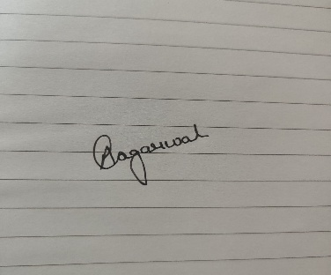_____________________
Student Name: AKRITI AGARWAL
Roll No.: 25SCS1003001686

ACKNOWLEDGEMENT

I am using this opportunity to express my gratitude to everyone who supported me throughout the Internship Program.
I am thankful to YuvaIntern for providing me with the opportunity to undertake an internship as a Junior Web Developer – E-Governance & Digital Services. The internship provided valuable exposure to responsive web design, digital-service architecture, quality assurance, software testing, accessibility, performance evaluation and security considerations.
I am sincerely grateful for the guidance, constructive feedback and support that helped me understand the practical aspects of designing and evaluating digital services. The internship also helped me develop a better understanding of user-centred design, testing methodologies, technical documentation and quality-oriented software development.
I express my gratitude to the School of Computer Science and Engineering, IILM University, my faculty members and my parents for their continuous encouragement, support and blessings throughout this internship.

Signature: ______________________
Student Name: AKRITI AGARWAL
Roll No.: 25SCS1003001686

INTERNSHIP COMPLETION CERTIFICATE
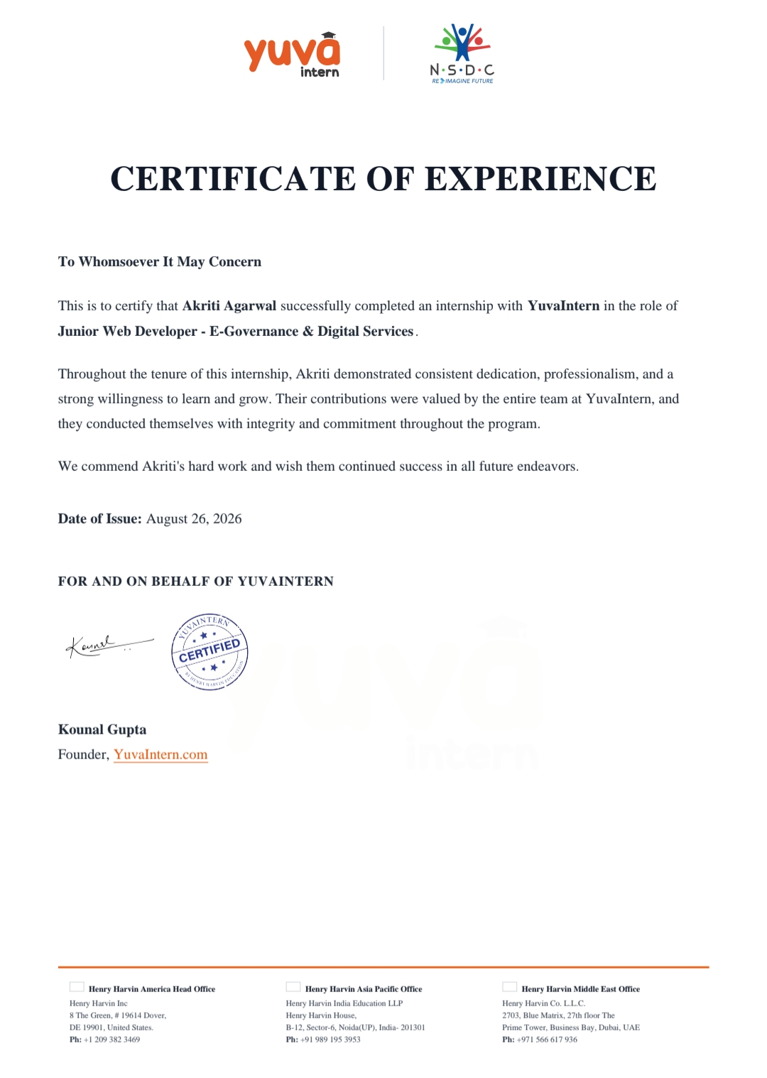

TABLE OF CONTENTS
Chapter No. | Chapter Name | Page No.
1 | Candidate's Declaration | I
2 | Acknowledgement | ii
3 | Internship Completion Certificate | iii
4 | Project Description | iv
4.1 | Introduction | 1
4.2 | Organization Profile | 2
4.3 | Problem Statement | 3
4.4 | Project Objectives | 4
4.5 | Scope of the Project | 5
4.6 | Technologies and Tools Used | 6
4.7 | System Architecture | 7
4.8 | Methodology | 8
4.9 | Expected Outcomes | 9
4.10 | Certificates of Completion and Communication Mail Proof | 10
5 | Bibliography / References | 13

LIST OF TABLES
Table No. | Title | Page No.
Table 4.1 | Internship Overview
Table 4.2 | Project Objectives
Table 4.3 | Project Scope
Table 4.4 | Technologies and Tools Used
Table 4.5 | System Components
Table 4.6 | Representative Test Cases
Table 4.7 | Performance Evaluation Metrics
LIST OF FIGURES
Figure No. | Title | Page No.
Figure 4.1 | System Architecture
Figure 4.2 | Primary User Flow
Figure 4.3 | Desktop Interface Prototype
Figure 4.4 | Mobile Interface Prototype
Figure 4.5 | Application Form Interface

4.PROJECT DESCRIPTION

4.1 Introduction
The internship provided practical exposure to the design, quality assurance, testing, and technical evaluation of a conceptual digital public-service platform. The project focused on understanding how an e-governance service can be designed to be responsive, accessible, usable, reliable, and secure.
The central project concept was CivicConnect, a conceptual and platform-agnostic digital public-services portal. It was designed to simplify common government-service journeys by helping citizens discover services, understand eligibility requirements, complete applications, submit necessary documents, and track the progress of their requests.
The project followed a task-oriented approach to digital service design, with the major user journey represented as Discover → Understand → Apply → Review → Submit → Track. The interface was planned around citizen needs rather than internal departmental structures, with emphasis on clarity, accessibility, responsiveness, usability, and trust.
Along with interface and responsive design considerations, the internship work included the preparation of a structured Quality Assurance and Testing Strategy. The strategy covered functional correctness, reliability, security, performance, usability, accessibility, compatibility, and recovery.
A technical evaluation framework was also considered for assessing performance, accessibility, security, privacy, reliability, monitoring, and operational readiness. Since the project was conceptual and no live production environment or production telemetry was available, the evaluation was benchmark-led rather than based on live production measurements.

4.2 ORGANIZATION PROFILE
YuvaIntern was the organization through which the internship was completed. The internship was undertaken in the role of Junior Web Developer – E-Governance & Digital Services for a period of four weeks.
The internship provided an opportunity to gain practical exposure to activities related to digital-service design, responsive web interfaces, quality assurance, testing, accessibility, performance evaluation, and security considerations. The work was focused on understanding the various aspects involved in planning and evaluating a reliable and user-oriented digital service platform.
During the internship, the work involved preparing and analysing technical deliverables related to a conceptual digital public-service platform. The experience provided practical understanding of how software quality can be approached through structured design practices, testing strategies, risk assessment, and technical documentation.
The internship also helped in developing an understanding of professional software-development practices, including systematic problem analysis, documentation, quality-oriented thinking, and consideration of user requirements while designing digital services.

4.3 Problem Statement
Digital public-service platforms are required to provide citizens with simple, accessible, responsive, reliable, and secure ways to access government-related services. However, users may face difficulties when services are not clearly organised, requirements are difficult to understand, forms are complicated, or application status is not communicated effectively.
The project therefore focused on the problem of designing a digital public-service platform that can support citizens throughout the complete service journey. The platform needed to enable users to discover relevant services, understand eligibility and requirements, complete application forms, submit necessary documents, receive confirmation, and track the progress of their applications.
Another important aspect of the problem was ensuring that the proposed platform maintained appropriate standards of usability, accessibility, performance, security, and reliability. Since digital public-service platforms may handle personal and application-related information, protecting user data and preventing unauthorised access are important considerations.
Therefore, the project addressed the following problem:
“How can a digital public-service platform be designed and evaluated so that citizens can discover services, understand requirements, complete applications, and track their requests through a clear, responsive, accessible, reliable, and secure interface?”

4.4 PROJECT OBJECTIVES
The primary objective of the project was to understand and apply a structured approach to designing and evaluating a digital public-service platform. The project focused on combining user-centred design with software quality, testing, accessibility, performance, and security considerations.
The major objectives of the project were:
- To design a responsive and user-oriented interface for a digital public-service platform.
- To organise public services in a clear and task-oriented manner to improve service discovery.
- To provide clear information regarding service eligibility, requirements, application procedures, and status tracking.
- To design application forms with appropriate validation, progress indicators, and error-handling mechanisms.
- To ensure that the proposed interface considers accessibility requirements and can be used across different devices and screen sizes.
- To develop a structured Quality Assurance and Testing Strategy covering functional and non-functional aspects of the platform.
- To identify suitable testing approaches for functionality, integration, regression, performance, security, usability, accessibility, compatibility, and reliability.
- To establish measurable criteria for evaluating application performance, including page performance, API response time, error rate, and availability.
- To identify important security considerations related to authentication, authorisation, input validation, sessions, APIs, file uploads, and sensitive information.
- To understand the importance of risk-based testing and release-readiness criteria in delivering reliable digital services.

4.5 SCOPE OF THE PROJECT
The scope of the project covers the conceptual design and quality evaluation of a digital public-service platform intended to provide citizens with a structured and user-oriented way of accessing digital services. The project focuses on the major stages of the citizen service journey, from discovering a service to submitting an application and tracking its progress.
The functional scope includes citizen registration and login, profile management, service search and filtering, service details, eligibility information, online application forms, document submission, application review and submission, confirmation and reference numbers, application status tracking, notifications, and help and support.
The project also considers administrative functions such as application review and role-based access control. These functions are important for ensuring that different users can access only the features and information appropriate to their roles.
From a quality perspective, the scope includes functional testing, integration testing, system testing, regression testing, performance testing, security testing, usability testing, accessibility testing, compatibility testing, and reliability and recovery testing.
The technical evaluation scope covers performance, accessibility, security, privacy, reliability, monitoring, operational readiness, dependency management, and risk assessment.
The project is limited to a conceptual and platform-agnostic solution. It does not represent a live production government website. No production source code, database, authenticated test environment, production URL, or real-time production telemetry was available. Therefore, the performance and security evaluation is based on defined benchmarks, testing criteria, and risk considerations rather than claims of live production measurements or vulnerability discoveries.

4.6 TECHNOLOGIES AND TOOLS USED
The project involved the use of web-development concepts, quality assurance practices, testing methodologies, and industry-standard frameworks for evaluating a digital public-service platform. The technologies and tools considered during the internship were selected to support responsive design, functional testing, performance evaluation, accessibility assessment, and security analysis.
4.6.1 Web and Interface Technologies
The project focused on responsive web interfaces and user-centred digital-service design. The interface was planned to work across desktop, tablet, and mobile screen sizes. The design system included consistent typography, controls, cards, forms, alerts, status indicators, and navigation components.
4.6.2 Testing and Quality Assurance Tools
Different tools and approaches were considered for evaluating the quality of the platform. Browser developer tools and Lighthouse can be used for performance and accessibility evaluation. Postman/Newman can be used for API testing and automation, while Playwright/Selenium can support UI and end-to-end testing. JMeter/k6 can be used for load and stress testing.
4.6.3 Security and Quality Standards
WCAG 2.2 was considered as the accessibility reference, with Level AA identified as the recommended target. OWASP Top 10 was used as a reference for common web-application security risks. Core Web Vitals, including LCP, INP, and CLS, were considered for evaluating user-perceived web performance.
4.6.4 Version Control and Automation
Version control and CI/CD practices can be used to maintain code changes, automate testing, and support consistent quality checks during development. Automated tests and quality gates can help identify defects before a release is considered ready.

4.7 SYSTEM ARCHITECTURE
The proposed digital public-service platform follows a layered architecture in which the user interface, application services, authentication, data storage, external services, and monitoring components work together to support the complete service journey.
The Web/Mobile Front End provides the citizen-facing interface through which users can search for services, view service details, complete application forms, upload documents, receive notifications, and track their applications.
The Application/API Layer manages the main business logic of the platform. It processes requests from the front end, performs validation, applies business rules, and communicates with the underlying services and data stores.
The Authentication Service is responsible for user authentication and session-related functions. It helps ensure that protected services and information are accessible only to authorised users.
The Database stores application and service-related information. Appropriate data-integrity and access-control mechanisms are required to maintain consistency and protect stored information.
Document Storage is used for handling documents submitted as part of applications. Uploaded files require appropriate validation and access controls to prevent unauthorised access or unsafe file handling.
External Services may be integrated with the platform for functions such as notifications, identity-related services, document services, or other required third-party functionality.
Finally, the Monitoring and Logging Layer supports operational visibility by collecting relevant logs, metrics, alerts, and other information required for troubleshooting, performance monitoring, and incident investigation.
Thus, the architecture separates the major responsibilities of the platform while allowing them to communicate through defined interfaces. This separation supports maintainability, security, scalability, and systematic testing of the digital service.
Figure 4.1
Citizen

Web / Mobile Front End End
Monitoring & Logging ────→ Application/API
External Services ───────→ Application/API
Authentication Service ──→ Application/API External Services ───────→ Application/API Monitoring & Logging ────→ Application/API
Document Storage
Database

Application / API Layer

4.8 METHODOLOGY
The methodology followed during the project was structured around the stages of understanding the requirements, designing the digital-service interface, defining quality assurance activities, preparing test scenarios, and evaluating performance, accessibility, security, and reliability.
Requirement Understanding: The first stage involved understanding the requirements of a citizen-oriented digital public-service platform and identifying the major activities involved in accessing and completing a service.
Information Architecture and User Flow: The service structure was organised around user tasks. The primary journey was considered as Discover → Understand → Apply → Review → Submit → Track. This approach was intended to make services easier to find and understand.
Responsive Interface Design: The interface was planned for different screen sizes, including desktop, tablet, and mobile devices. Navigation, forms, controls, and content were considered according to the available screen space and interaction method.
Accessibility and Usability: Accessibility and usability were considered during the design process. Important considerations included keyboard accessibility, visible focus indicators, readable content, clear form labels, appropriate contrast, understandable error messages, and suitable touch targets.
Quality Assurance and Testing: A structured testing approach was defined to evaluate functional and non-functional aspects of the platform. The approach included functional, integration, system, regression, performance, security, usability, accessibility, compatibility, and reliability testing.
Test Case Preparation: Representative test scenarios were prepared for important user journeys such as registration, login, service search, application submission, input validation, document upload, status tracking, authorisation, notifications, and logout.
Performance Evaluation: Performance was considered using indicators such as Largest Contentful Paint (LCP), Interaction to Next Paint (INP), Cumulative Layout Shift (CLS), Time to First Byte (TTFB), API latency, error rate, throughput, and availability.
Security Evaluation: Security considerations included authentication, authorisation, input validation, session security, API protection, file-upload security, sensitive-data protection, dependency security, and audit logging.
Defect Management and Release Readiness: Defects were intended to be documented with their severity, priority, reproduction steps, expected and actual results, evidence, ownership, and retest status. Release readiness was considered based on the completion of critical testing, security checks, regression testing, and defined quality criteria.

Figure 4.2
Requirement Understanding → Design → Testing → Evaluation → Documentation

4.9 EXPECTED OUTCOMES
The project was expected to provide a structured understanding of how a digital public-service platform can be designed and evaluated with a focus on usability, accessibility, performance, security, and reliability.
The major expected outcomes of the project were:
- A clear and task-oriented digital-service interface that helps citizens find and understand relevant services.
- Responsive layouts that support usability across desktop, tablet, and mobile screen sizes.
- Improved service discovery through organised service categories, search, filtering, and clear service information.
- Easier application completion through structured forms, progress indicators, validation, and clear instructions.
- Better error recovery through understandable and actionable error messages.
- Transparent application tracking through status information and application history.
- Consideration of accessibility requirements so that the proposed service can be used by a wider range of users.
- A structured Quality Assurance and Testing Strategy covering both functional and non-functional testing.
- Defined performance criteria for evaluating page performance, API response time, error rate, throughput, and availability.
- Identification of important security risks related to authentication, authorisation, input validation, sessions, APIs, file uploads, and sensitive information.
- A systematic approach to defect management, risk prioritisation, and release readiness.
- Improved understanding of professional software-development practices, technical documentation, and quality-oriented thinking.

4.10 CERTIFICATES OF COMPLETION AND OTHER COMMUNICATION MAIL PROOF
The internship completion certificate issued by YuvaIntern is attached as evidence of successful completion of the internship. The certificate confirms the completion of the internship in the role of Junior Web Developer – E-Governance & Digital Services. The certificate was issued on 26 August 2026.

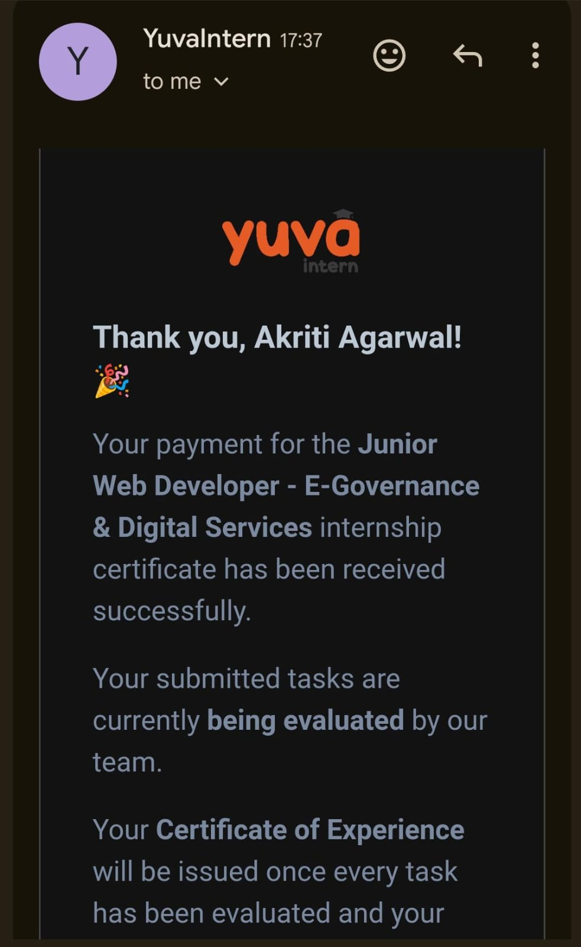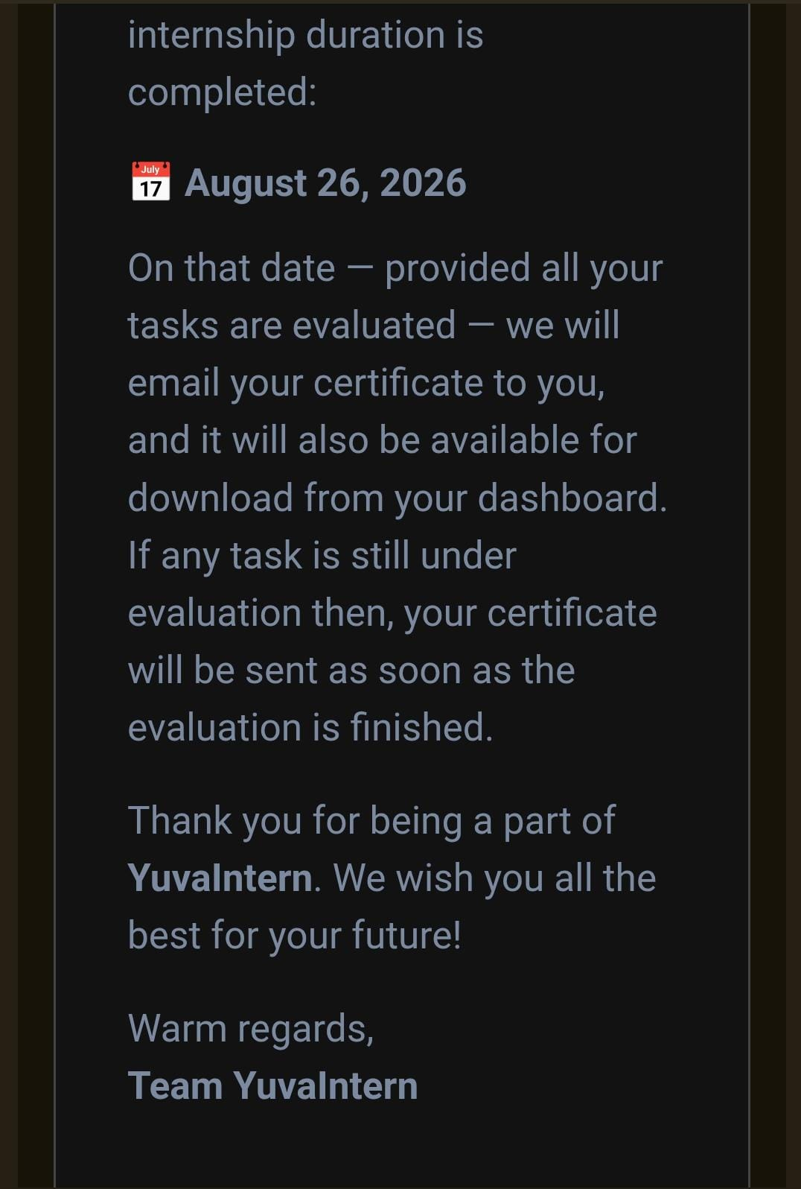

5. BIBLIOGRAPHY / REFERENCES
• YuvaIntern. Internship Completion Certificate – Akriti Agarwal, Junior Web Developer – E-Governance & Digital Services. August 26, 2026.
• IILM University, School of Computer Science and Engineering. Internship Report Format Updated 26–27.
• YuvaIntern Internship Technical Deliverable. Responsive Web Prototype for Digital Services: Design Documentation.
• YuvaIntern Internship Technical Report. Quality Assurance & Testing Strategy for Digital Services
• YuvaIntern Internship Technical Audit Report. E-Governance Digital Service Platform: Performance, Accessibility & Security Audit Report.

